**

**VOLUNTEER APPLICATION PACKET**

**HIRING CHECKLIST**

**APPLICANT NAME:**_______________________________________________________________

**DESCRIPTION OF DUTIES:**________________________________________________________

**WILL THE VOLUNTEER BE WORKING MORE THAN 2 WEEKS?**  **YES**  **NO**

**WILL THE VOLUNTEER NEED IT ONBOARDING?**  **YES**  **NO**

**WILL THE VOLUNTEER NEED CREDIBLE ACCESS?**  **YES**  **NO**

**INSTRUCTIONS FOR SUPERVISORS:**

*Please complete this Hiring Checklist and provide the rest of the Volunteer Application Packet to your candidate. Once all paperwork has been completed, forward a copy to Human Resources. HR cannot confirm employment or coordinate New Employee Orientation scheduling until each of these items have been received:*

* PAF – required for all Volunteers EXCEPT:
  + Those volunteering for less than 2 weeks
  + Bailey Peer Center Team Members
* Volunteer Application Packet, *which includes:*
  + *Hiring Checklist*
  + *Application for Employment*
  + *Background Check Disclosure Form*
  + *DataQuest Authorization Form*
  + *Equal Opportunity Employer Form*
  + *Drug Free Workplace Policy / Statement*
  + *Oath of Confidentiality*
  + *Code of Ethics & Mandatory Reporting Information*
  + *Anti-Discrimination Policy Statement*
* Resume
* Interview Notes *(if applicable)*

*Send completed paperwork to HR at* [*HR@compassh.org*](mailto:HR@compassh.org) *or Mailstop 42*

**

Application for Employment

*(Please Print)*

*Please complete this application in its entirety. Incomplete applications or responses may result in an applicant being ineligible for employment. Compass Health promotes equal treatment and equal employment opportunity to all applicants and employees regardless of race, ethnicity, creed, color, national origin, sex, religion, age, marital status, sexual minority status, sexual orientation, veteran status or disability unless based on a bona fide occupational qualification.*

|  |  |  |  |  |  |  |
| --- | --- | --- | --- | --- | --- | --- |
| POSITION(S) DESIRED | | | | | | APPLICATION DATE |
| LEGAL NAME: LAST | | FIRST | | | | MIDDLE |
| ADDRESS | | CITY | | | STATE | ZIP CODE |
| TELEPHONE NUMBER(S) | | | EMAIL ADDRESS | | | |
| EMERGENCY CONTACT NAME | RELATIONSHIP | | | | | PHONE NUMBER |
| HOW DID YOU HEAR ABOUT US?  *(Please be specific. If you were referred by a current employee, please include their name)* | | | | PREFERRED NAME *(For Agency email & phone)* | | |

1. If you are under 18 years of age, can you provide proof of your eligibility to work?.................. **Yes  No**
2. Have you ever applied for work with Compass Health before? ................................................ **Yes  No**

*If “Yes”, give date(s) of previous application:* ___________________________________________________________________

1. Have you ever been employed by Compass Health before?.................................................... **Yes  No**

*If “Yes”, give dates of previous employment:* ___________________________________________________________________

1. Describe any pertinent certifications, registrations, specializations, and/or licenses you hold:

___________________________________________________________________________________________________________________________________________________________________________________________________________________________________________________________________________________________________

**APPLICANT STATEMENT**

*I certify under penalty of perjury that the answers and responses given herein are true, accurate, and complete. I hereby authorize Compass Health to fully investigate and verify any statement, representation, or other information about me of any nature whatsoever including (but not limited to): 1) Any and all verbal and written statements and information I provide at any time during the hiring process, to secure employment, or thereafter to maintain employment, or 2) Information contained in this application, my resume, or in any other document related to hiring.*

*I hereby fully release Compass Health and all other persons and parties contacted by Compass Health who provide information or opinions to Compass Health about my character, past employment, conduct, or qualifications from any and all claims or damages of any nature whatsoever arising out of providing Compass Health opinions, statements, documents, or any other information about me. In the event of employment, I understand that false, incomplete, or misleading information or omissions I provide at any stage of the hiring process including, but not limited to, in a resume, interview(s), or application will be sufficient cause for discharge regardless of when discovered. I understand, also, that I am required to abide by all policies, procedures, ethical guidelines, and rules and regulations of Compass Health.*

**Signature: ___________________________________________________________________________________**

**Name of Applicant: _______________________________________________ Date: __________________**



**BACKGROUND CHECK DISCLOSURE FORM**

Pursuant to the federal Fair Credit Reporting Act (“FCRA”) and its applicable state counterparts, Compass Health may obtain consumer reports* or investigative consumer reports** on you for employment purposes in connection with your employment, potential employment, contract for services, volunteer position, or other employment-related purpose. Compass Health may procure consumer reports on you both in connection with your application, and, if applicable, at any time during the course of your employment, contract for services, or volunteer position with the Company. For more information about the FCRA, please reference “A Summary of Your Rights under the Fair Credit Reporting Act” found at: <https://www.consumer.ftc.gov/articles/pdf-0096-fair-credit-reporting-act.pdf>

Compass Health obtains background information for employment purposes from private consumer reporting agency DataQuest, LLC, as well as publicly accessible State and Federal databases including but not limited to Washington State Patrol’s WATCH database, the National Sex Offender Registry, and the OIG Exclusions database.

You have the right to dispute incomplete or inaccurate information in your consumer report. You have the right, for a reasonable time after receipt of this notice, to make a written request for a complete and accurate disclosure of the nature and scope of the investigation requested by Compass Health, as well as to receive a written summary of your rights and remedies under the law:

* Inquiries and/or requests regarding DataQuest reports should be directed to DataQuest, LLC: PO Box 1308, Snohomish WA 98291 or by phone at 888 – 443 – 0135. You may also visit their website at [www.dataquestllc.com](http://www.dataquestllc.com) for additional information regarding DataQuest’s privacy practices services, and representative contact information.
* Inquiries and/or requests regarding State and Federal database reports should be directed to Compass Health Human Resources: *4526 Federal Avenue (Building #8), Everett WA 98203* or by phone at *425 – 349 – 8437*

*\* Consumer reports are written, oral, or other communications that bear on your creditworthiness, credit standing, credit capacity, character, general reputation, personal characteristics, or mode of living that are used (or expected to be used) as a factor in establishing eligibility for employment purposes. Consumer reports may include items such as employment verifications, education verifications, credit history, driving records, criminal history, motor vehicle records, licensures, certifications, social security number verification, drug testing results, or other information obtained through background check services. The information may be obtained from private and public record sources, including personal interviews.*

*\*\* Investigative consumer reports are consumer reports (or portions of consumer reports) in which information is obtained through personal interviews with your neighbors, friends, associates or acquaintances, and are commonly obtained in connection with education or employment reference checks. In California an investigative consumer report means any consumer report that is not a credit report.*

**APPLICANT DISCLOSURE / ACKNOWLEDGEMENT OF RECEIPT**

1. **Have you ever been charged or convicted of any crime?**...........................................................................**NO**  **YES**

*If “yes”, please provide an explanation including dates, the nature/severity of the charge, and all other applicable details:*

___________________________________________________________________________________________

___________________________________________________________________________________________

___________________________________________________________________________________________

1. **Have any complaints or charges been reported or filed against you in a judicial or administrative adjudication proceeding by an organization where you were either employed or volunteered?**..................................**NO**  **YES**

*If “yes”, please provide an explanation including dates, the nature/severity of the charge, the final outcome of the proceeding and all other applicable details:*

___________________________________________________________________________________________

___________________________________________________________________________________________

___________________________________________________________________________________________

I confirm that I have read and understand this Background Check Disclosure Form, and swear to the accuracy of the content I provided in the Applicant Disclosure section, under penalty of perjury.

**Applicant Signature:** ______________________________________________________________ **Date:** ___________

**Applicant Print Name:** _______________________________________________________________________________

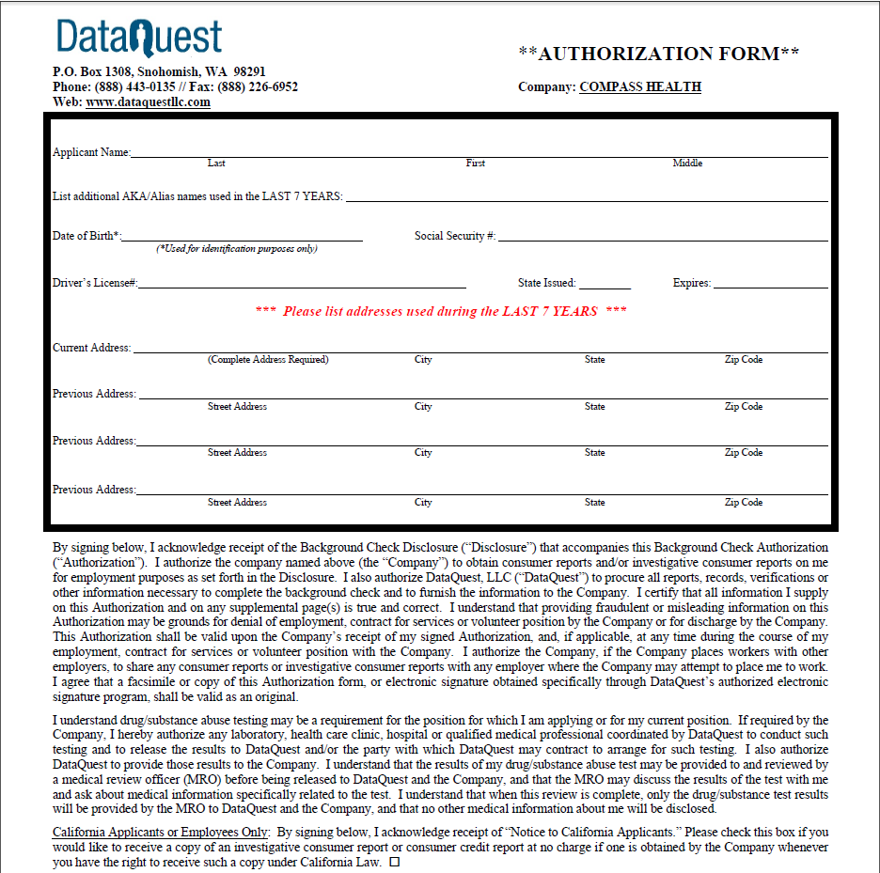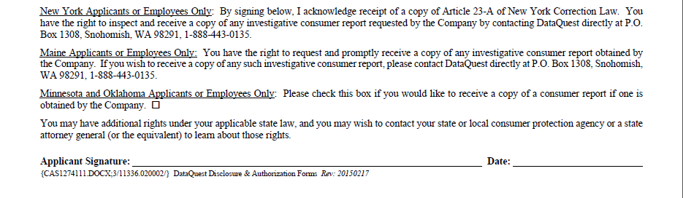



**EQUAL EMPLOYMENT OPPORTUNITY FORM**

Compass Health is an Equal Opportunity Employer. The following information is being requested of all applicants for employment. Providing this information is STRICTLY VOLUNTARY. This self-identification request is made in compliance with the regulations issued by the Government, and will assist us with monitoring, record keeping, and periodic reporting. *This information will be kept separate from your application and will not be used in a discriminatory manner.*

NAME: ___________________________________________________________________________ DATE**:** __________

POSITION FOR WHICH YOU ARE APPLYING: ____________________________________________________________

HOW DID YOU LEARN ABOUT THIS POSITION?_________________________________________________________

**PLEASE CHECK ALL THAT APPLY:**

**Gender:**  Male  Female  Decline to answer

**Age Over 40?**  Yes  No  Decline to answer

**Veteran Status:**

Vietnam Era Veteran (between 02/28/1961 and 05/07/1975

Disabled Veteran (receiving 30% military disability)

Other Protected Veteran

Armed Forces Service

Campaign Veteran (recently separated: discharged or release of duty within the last year)

Decline to answer

**Race:**

Hispanic or Latino

Caucasian

Black or African American

Two or More Races

Native Hawaiian or Other Pacific Islander

Native American or Alaska Native

Asian

Decline to answer

**Presence of a work-restricting handicap (physical, mental, or sensory)?**  Yes  No  Decline to answer

*If “Yes”, please explain:* _______________________________________________________________________________



**DRUG FREE WORKPLACE POLICY / STATEMENT**

Compass Health is a drug free workplace. The use, possession, manufacture, cultivation, distribution, or dispensing of controlled substances as defined in RCW 69.50, The Uniformed Controlled Substance Act, or other intoxicants (such as alcoholic beverages) is prohibited at any location where Compass Health business is conducted. Further, the use, sale, or possession by an employee of liquor, controlled substances, drugs not medically authorized, or other substances that may impair job performance or pose a hazard to the safety and welfare of the workforce member, the public, or clients, is strictly prohibited and may result in discipline, up to and including termination of employment.

All workforce members’ who suspect they may have an alcohol or substance abuse problem are urged to report the matter to the Human Resources Department before the problem affects their employment status. If Compass Health suspects a workforce member may be in violation of this policy, Compass Health may request that the workforce member promptly take a drug and alcohol test and/or undergo an assessment. Workforce members must fully cooperate in any testing and/or assessment process or be subject to discipline, up to and including termination of employment.

A workforce member who has knowledge of another workforce member in a condition that impairs his or her ability to perform tasks in a safe and sure manner must immediately report the matter to the supervisor of the workforce member and/or the Human Resources Department.

As a general condition of employment with Compass Health, and as a specific and express condition of employment on a federal contract, each workforce member must abide by the terms of this policy. Workforce members must also notify Compass Health if they are convicted of a criminal drug statute violation occurring in the workplace no later than five days after such conviction. Within 30 days of such notice from the employee, or from the date Compass Health receives actual notice of any employee’s conviction, Compass Health will take appropriate disciplinary action against the convicted employee.

**Acknowledgement:**

*I have read and understand the Drug-Free Workplace Policy / Statement and agree to abide by the conditions set forth. I have had the opportunity to discuss and ask questions regarding this information. I further understand the importance placed on confidentiality and that failure to comply with the Compass Health policies is considered cause for immediate dismissal.*

**Workforce Member Signature:** ______________________________________________________ **Date:** ___________

**Workforce Member Print Name:** _______________________________________________________________________



**OATH OF CONFIDENTIALITY**

Compass Health staff protect all information, records, and data collected from unauthorized disclosure in accordance with 42 CFR 431.300 through 431.307, RCW’s 70.02, 71.05, and 71.34, HIPAA, and for client receiving alcohol and drug abuse services, in accordance with 42 CFR Part 2, 45 CFR Parts 160 and 164, and RCW 70.96A.

I, the undersigned, hereby agree not to divulge any Compass Health confidential information, including Protected Health Information without proper authorization, and in accordance with state and federal law. This includes confidential company financial information or employee information. I recognize that any discussion of or release of confidential information to any unauthorized person is forbidden and may be grounds for legal and/or disciplinary action.

During the performance of my assigned duties, I may have access to confidential information required for the performance of my job duties. I agree that all discussions, deliberations, records, and information generated or maintained in connection with these activities will not be disclosed to any unauthorized person.

Access to client records is limited to Compass Health clinical and clerical staff for the specific use of their job function. All records and other written material concerning clients will be locked up when not in use.

The fact of admission, pertinent information or records may be released when:

1. The client consents in writing.
2. The agency is court-ordered to release information.
3. By law the agency is required, under certain circumstances, to release information to law enforcement, public health officials, department of corrections, or designated mental health professionals.

There are exceptions to the privacy rules that allow us to disclose or exchange information without authorization. These exceptions are outlined in our Notice of Privacy Practices.

**Acknowledgement:**

*I have read and understand the Oath of Confidentiality and agree to abide by the conditions set forth. I have had the opportunity to discuss and ask questions regarding this information. I further understand the importance placed on confidentiality and that failure to comply with the Compass Health policies is considered cause for immediate dismissal. I understand that these requirements related to confidentiality do not cease at the time I terminate my relationship with Compass Health and I agree to be permanently bound by this oath and by the regulations of confidentiality henceforth.*

**Workforce Member Signature:** ______________________________________________________ **Date:** ___________

**Workforce Member Print Name:** _______________________________________________________________________

**Witness Signature:** _______________________________________________________________ **Date:** ___________

**Witness Print Name:** ________________________________________________________________________________



**CODE OF ETHICS & MANDATORY REPORTING INFORMATION**

The following Code of Ethics embodies specific standards of behavior for a Compass Health worker in his/her relationships with those served, with colleagues, with other practitioners, and with the community. In abiding by this Code of Ethics, a Compass Health Workforce Member views his/her obligations in as wide a context as the presenting situation requires, considers principles of sensitivity and humanness, and chooses a course of action which complies with the Code's letter and intent. All Workforce Members must abide by the Code of Professional Conduct outlined by their Washington State Registration, Certification or License and the codes of ethics of their profession. All personnel, professional and support workforce members, regardless of their role in the agency, must comply with the Compass Health Code of Ethics.

When ethical issues about clients, Workforce Members, or agency policy arise, consultation with the Workforce member’s supervisor must occur immediately.

**All Workforce Members will follow the following Compass Health Code of Ethics:**

* I regard as my primary obligation the welfare of the individuals whom I serve.
* I will not discriminate on the basis of race, color, religion, age, sex, marital status, sexual orientation, veteran status, disability, or national ancestry. In my work capacity, I will attempt to prevent and eliminate such discrimination in rendering service.
* I will protect the confidentiality and the identity of all Compass Health clients and any information about them (please refer to Chapter 3 of the Workforce Handbook).
* I give precedence to my professional responsibility over my personal interest. A client may include an individual you provide direct service to, has received services from your direct clinical team or an individual that you have direct knowledge of their therapeutic treatment at Compass Health. I understand that Compass Health is concerned about my relationships with clients and/or their family/guardian that are, or could appear to be, exploitive and/or unethical. These relationships include, but are not limited to, personal friendships developed with clients and/or their family/guardian, business transactions with clients and/or their family/guardian, and receiving valuable gifts, favors or services. I acknowledge that professional clinical relationships extend beyond the client's formal termination from services. Workforce members are required to consult with their supervisor, Director, or Human Resources with any potential dual relationship (please refer to Self-Disclosure sections within the Compass Health Workforce Handbook).
* I will not have sexual or intimate contact of any kind with any client. Sexual or intimate contact between a workforce member and a former client is unethical.
* I understand that initiating any contact with clients after my termination of employment is potentially unethical and strongly discouraged. I will refrain from initiating contact with Compass Health clients upon my termination of employment for at least 2 years or while the individual is still a client of Compass Health, whichever is later.
* I will accurately represent my professional qualifications, associations and affiliations.
* I will under no circumstances render services while under the influence of alcohol, drugs not medically authorized, or any substance that may impair job performance.
* I will make every effort to avoid public situations that could be construed as improper. Workforce Members are always representing the agency (even when off duty).
* I will always handle Compass Health money with the utmost integrity and according to Compass Health policies. I will not intentionally co-mingle Compass Health money with my personal money. Any concerns around the handling of money will be immediately discussed with my supervisor.
* I fully understand and acknowledge my commitment as a workforce member to comply with the Compass Health regulatory compliance plan. I will promptly report any possible violation to the compliance officer.
* I will maintain any registration or licensure required for my work at Compass Health without lapse. I acknowledge that any lapse in required registration or licensure will result in suspension without pay, and may require Compass Health to terminate my employment if my registration or licensure is not restored immediately.
* If I am aware of circumstances within Compass Health that I feel impair Compass Health's or my effectiveness, morale and efficiency in the delivery of services, I will make every effort to bring about positive change through appropriate channels.
* If concerns are not resolved through ordinary Compass Health organizational channels, I will use the Compass Health problem-solving procedures (See Section AA, page 26 of the Workforce Handbook).
* If I am unable to bring about positive change on these issues, I will refrain from behavior which either embarrasses or results in poor morale, ineffectiveness, or damage to the therapeutic efforts of Compass Health.

**Mandatory Reporting (refer to policy #AC-210):**

* All Compass Health workforce membersare mandated to make a report when they have reasonable cause to believe that a child or vulnerable adult has suffered abuse or neglect. This is true even if the mandatory reporter has been told that a report has already been made.
* Mandated reports must be made tothe appropriate department (Child Protective Services (CPS) for children, Adult Protective Services (APS) for adults);and law enforcement when appropriate. Both APS and law enforcement must be informed when there is reason to suspect sexual or physical assault of a vulnerable adult.
* When there is reasonable cause to believe that abuse/neglect has occurred, an immediate report must be made as soon as possible after the safety of child/adult is established but in no case longer than 48 hours.
* Upon receiving a report of alleged abuse and neglect; APS, CPS, or investigating law enforcement agency shall have access to all relevant records (about the person regarding whom the report was made) in the possession of the mandated reporters and their workforce.(RCW 26.44.030) This is true regardless of whether the client or the client’s guardian has signed a release. The exception to this rule is Chemical Dependency Records, which are protected by CFR 42 Part 2 Sec 2.13, and should not be released without appropriate authorizations.
* When a clinician is unclear as to whether an incident warrants reporting, the clinician should call CPS/APS to discuss whether a report is warranted: consult with Supervisor.

**Acknowledgement:**

*I acknowledge receipt of the Compass Health Code of Ethics and Mandatory Reporting Information and accept responsibility for familiarizing myself with the policy and procedures it contains.*

**Workforce Member Signature:** _________________________________________________________ **Date:** ___________

**Workforce Member Print Name:** _________________________________________________________________________



**ANTI-DISCRIMINATION POLICY STATEMENT**

**Equal Employment Opportunity Policy/Statement**: Compass Health is an equal opportunity employer. All employees and potential employees will be recruited, selected, trained, promoted and transferred regardless of race, creed, color, national origin, sex, religion, age, marital status, sexual minority status, sexual orientation, veteran status or disability unless based on a bona fide occupational qualification. Any questions or compliance concerns related to equal employment opportunity should be directed to Human Resources at (425) 349-8473.

**Non-Discrimination Policy/Statement**: Compass Health is committed to the policy that all persons shall have access to its programs, activities, facilities, and employment without regard to race, color, religion, creed, national origin, sex, age, marital status, sexual minority status, sexual orientation, veterans status or disability. The Compass Health Diversity Plan describes specific goals and activities Compass Health is pursuing to increase and honor diversity.

**HIV/AIDS Non-Discrimination Policy/Statement**: Our non-discrimination policy specifically includes HIV/AIDS or any person related to, residing with or associated with someone with HIV/AIDS; or any person perceived to have or be associated with a person perceived to have HIV disease/AIDS. This non-discrimination is practiced in employment and services.

**Reasonable Accommodation Policy/Statement**: Compass Health will provide reasonable accommodation for persons of disability and ensure against discrimination because of a person’s disability. Compass Health encourages applicants and employees with disabilities to request accommodations, when needed for recruitment, interviewing and/or to enjoy the benefits, privileges and responsibilities of employment. Compass Health will provide reasonable accommodation for applicants and employees with a disability consistent with applicable laws and regulations in the State of Washington. Please call Human Resources at 425-349-8473 regarding reasonable accommodation.

**Anti-Harassment Policy/Statement**: It is the policy of Compass Health to maintain a work environment free from all forms of harassment and to insist that all employees be treated with dignity, respect, and courtesy.

Any comments or conduct relating to a person's race, religion, age, disability, marital status, veteran status, ethnic background or other protected group status which fail to respect the dignity and feelings of the individual are unacceptable. This policy extends to comments or conduct of a sexual nature, where such behavior tends to threaten or offend a fellow employee, client or visitor. Compass Health has a no tolerance policy for any such inappropriate behavior or language, even if stated in a joking manner.

**Anti-Sexual Harassment Policy/Statement**: Compass Health will not tolerate harassing conduct that affects tangible job benefits, that interferes unreasonably with an individual’s work performance, or that creates an intimidating, hostile, or offensive working environment.

Sexual harassment deserves special mention: Unwelcome sexual advances, requests for sexual favors, and other physical, verbal, or visual conduct based on sex constitute sexual harassment when: Submission to the conduct is an explicit or implicit term or condition of employment, or submission to or rejection of the conduct is used as the basis for an employment decision, or the conduct has the purpose or effect of unreasonably interfering with an individual’s work performance or creating an intimidating, hostile, or offensive working environment. Sexual harassment may include explicit sexual propositions, sexual innuendo, suggestive comments, sexually oriented “kidding” or “teasing”, “practical jokes”, jokes about gender-specific traits, request to date or socialize, foul or obscene language or gestures, displays of foul or obscene printed or visual material, and physical contact, such as patting, pinching, or brushing against another’s body.

*Process for Sexual Harassment, Harassment or Discrimination Complaints*: Any employee believing that he or she has been the object of harassment or discrimination must immediately report any such incident to his or her supervisor. If the supervisor is the cause of the problem or if he or she seems unwilling to resolve the issue, the employee must immediately contact the next level of management. For any complaints of sexual harassment or discrimination the employee may also directly contact Human Resources at (425) 349-8473.

Every reported incident of employee harassment or discrimination will be thoroughly and promptly investigated by management with the cooperation of the employee. To the extent possible, management shall respect the confidences and sensitivities of all persons involved in the incident. The concerned employee or any participants in an investigation of such reports will be afforded protection from retaliation, and the results of any investigation of alleged harassment shall promptly be communicated to the employee. Where charges of employee harassment are substantiated, appropriate corrective action will be taken. Appropriate action might range from counseling to termination.

**ACKNOWLEDGEMENT OF RECEIPT:**

*I acknowledge receipt of the Compass Health Policy / Statement regarding anti-discrimination and accept responsibility for familiarizing myself with the policy and procedures it contains.*

**Workforce Member Signature:** ______________________________________________________ **Date:** ___________

**Workforce Member Print Name:** _______________________________________________________________________



**WORKFORCE MEMBER HANDBOOK ACKNOWLEDGEMENT FORM**

I acknowledge and agree that the Workforce Member’s Handbook, and any other written and verbal policy statements by any representative of Compass Health, do not constitute a set of promises or an employment contract. I also understand that this Handbook and any other statements by Compass Health do not constitute an express or implied promise of specific treatment in specific situations.

I understand that my employment with Compass Health will continue at the will of the Agency and myself, and may be terminated at any time for any reason by either party with or without cause, notwithstanding any statement in the Handbook or its subsequent revision or any covenants implied by law.*

I acknowledge and agree that the Workforce Member’s Handbook supersedes and replaces any and all handbooks, manuals, and policy statements (both written and verbal) that I have received.

I further acknowledge and agree that any verbal and written representations from Compass Health representatives will not supersede the terms addressed in this acknowledgement.

I have received a copy of the Workforce Member’s Handbook and I accept responsibility for familiarizing myself with the policies and regulations it contains.

Any questions I have concerning this acknowledgement were answered to my satisfaction.

**Workforce Member Printed Name:** _____________________________________________________________________

**Workforce Member Signature:** _________________________________________________________ **Date:** ________

**Witness Printed Name:** ______________________________________________________________________________

**Witness Signature:** ___________________________________________________________________ **Date:** ________