Tip Sheet – Request to Access a Record
The Request to Access a Record (RAR) form is to use when you want to obtain a copy of your own record. You can also use it to request a copy of your child’s record if they are under 13, or the record of someone for whom you are the legal guardian. If you have a valid Release of Information (ROI,) you can use this form to request someone else’s records!
There is a fee when you request copies of a record. The fee agreement worksheet is included with the RAR to help you understand what it will cost.
Personal information
Fill out the top section with information about the client, and how to contact the person who is requesting.
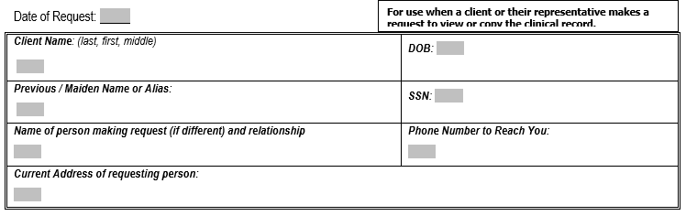
What information do you want?
Here is where you tell us exactly what you want us to send you. Because there can be a cost associated with getting records, it can be helpful to be specific. Feel free to write in your request under “Other” or give us a call to talk about where you would find the information you are most interested in.
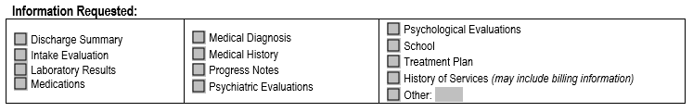
Also tell us the dates you are interested in. For example, if you’ve been to Compass Health 3 times over the past 10 years, do you want information from all of those times, or just the most recent one? Do you want to simply view the record, or be provided with a copy?
Who are you?
Finally, tell us who you (the requestor) are, and why you have the right to this record. If you’re the client, that’s easy! If you are the guardian, you will need to attach evidence of that. If you are someone else altogether, you can still use this form to request specific records, but you’ll need to attach an ROI. Then, please sign!
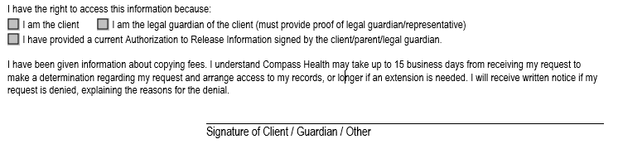
Fee Agreement
This section talks about the cost of receiving records. You can choose to receive paper copies, in which case the cost depends on the number of pages; or a USB drive or email, which costs $10 plus tax. There are times when fees do not apply – please call us at (425) 349-8386 if you have questions about fees in your specific circumstance.
Please use the checkboxes to indicate whether you want to be notified of an estimate before the work is done. If we process your request, you will be charged. Note that for paper copies, the cost can vary widely.
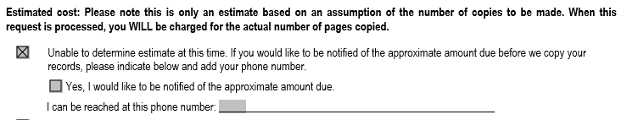
Then, please sign to verify that you’re aware of the fees.
Thank you for your attention to this form!!

